Algebra 1 Name:
Day 9 Practice – Average Rate of Change
1. Use the graph below to find the average rate of change over the given intervals.
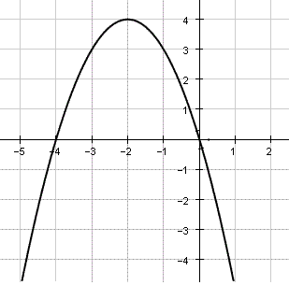
a) $-5≤x≤-2$

b) $-2≤x≤1$

c) $-1≤x≤0$

2. Use the equation below to find the average rate of change over the given intervals.
a) $-7≤x≤-4$ b) $-5≤x≤-4$ c) $-3≤x≤0$

